Predictive capability of a smart hospital bedroom equipped with passive infra-red sensors and artificial intelligence in France

Soütrik Banerjee,
1st March, 2017

Data ScienceTech Institute
4, rue de la Collégiale
75005 Paris

- Background
Elderly subjects in the hospitals suffering from different stages of cognitive impairment can have different behavioural problems related to their disease. One of these could be nocturnal wandering and when it becomes excessive, it takes the form of nocturnal agitation. The latter is a nuisance for the night time personnel, when they are reduced in number and efficiency in their duty hours. Telesurveillance using passive infra-red sensors (PIRS) can provide useful information to the health personnel and doctors in order to control behavioural problems in such patients by titration of medications and other measures. In this study, activities of 27 elderly patients often suffering from various stages of dementia (n = 21) or having normal cognitive function (n = 6) were followed using eight PIRS in a geriatric hospital bedroom, “chambre intelligente” in Grenoble. This study is described in detail elsewhere. In brief, the activity chart generated by the system print-out every morning was interpreted as “agitated” or “not” by three independent “experts”, who were trained to read such charts. This provided the ‘subjective’ evidence of the “presence” or “absence” of nocturnal agitation. This was the outcome or label variable for the analysis. In order to predict this outcome, which would provide a measure of the reliability of the system and a future means of automation to detect nocturnal agitation, an objective measurement of total duration of activity recorded by the sensors (in minutes), a frequency (or count) of movements during each 15-minute interval, and an assessment of dementia status (yes or no) by the Mini-mental state exam (MMSE) during the time window from midnight until 6 a.m. were recorded. These three ‘objective’ variables – duration of activity, frequency of activity and dementia status were the predictor variables for the analysis. In total 352 nights’ activities (= observations) were recorded. Different methods and criteria using different software were used for supervised learning.
- Results
- Matlab
A 10-fold cross-validation (CV) was undertaken to select the optimal parameters, wherever tuneable, for the best model for each of the methods. Validation accuracy was chosen as the criterion to judge the best model.
Table showing methods, model fit statistics (CV accuracy) and optimal parameter values.
Method | Validation accuracy | Optimal parameter and value
Naïve Bayes | 0.918 | NA
Linear kernel “SMO” SVM | 0.946 | Cost (C) ~ 1
Quadratic kernel “SMO” SVM | 0.949 | Cost (C) ~ 5
Cubic kernel “SMO” SVM | 0.954 | Cost (C) ~ 12
Gaussian kernel “SMO” SVM | 0.954 | Cost (C) ~ 6, Scale (S) ~ 2.5
Decision tree | 0.940 | Maximum number of splits = 3
k-Nearest neighbours | 0.952 | Number of nearest neighbours = 12
Ensemble methods
Ada boosting | 0.949 | Maximum number of iterations = 9, learning rate = 0.1
Total boosting | 0.923 | Maximum number of iterations = 48
LP boosting | 0.909 | Maximum number of iterations = 4
Gentle boosting | 0.946 | Maximum number of iterations = 2, learning rate = 0.1
Robust boosting | 0.946 | Maximum number of iterations = 1
Logit boosting | 0.940 | Maximum number of iterations = 1, learning rate = 0.1
RUS boosting | 0.912 | Maximum number of iterations = 58, learning rate = 0.1
Subspace (type = discriminant) | 0.926 | Maximum number of iterations = 7
Bagging | 0.940 | Maximum number of iterations = 9
Ada boosting (exponential loss) | 0.637 | Maximum number of iterations = 30, learning rate = 0.1
Total boosting (exponential loss) | 0.313 | Maximum number of iterations = 60
LP boosting (exponential loss) | 0.195 | Maximum number of iterations = 15
Gentle boosting (exponential loss) | 0.506 | Maximum number of iterations = 60, learning rate = 0.1
Robust boosting (exponential loss) | 0.536 | Maximum number of iterations = 4
Logit boosting (exponential loss) | 0.607 | Maximum number of iterations = 30, learning rate = 0.1
RUS boosting (exponential loss) | 0.841 | Maximum number of iterations = 60, learning rate = 0.1
Subspace (type = discriminant, exponential loss) | 0.573 | Maximum number of iterations = 2
Bagging (exponential loss) | 0.583 | Maximum number of iterations = 60
Ada boosting (hinge loss) | 0.842 | Maximum number of iterations = 17, learning rate = 0.1
Total boosting (hinge loss) | 0.427 | Maximum number of iterations = 60
LP boosting (hinge loss) | 0.239 | Maximum number of iterations = 15
Gentle boosting (hinge loss) | 0.749 | Maximum number of iterations = 60, learning rate = 0.1
Robust boosting (hinge loss) | 0.819 | Maximum number of iterations = 3
Logit boosting (hinge loss) | 0.849 | Maximum number of iterations = 20, learning rate = 0.1
RUS boosting (hinge loss) | 0.974 | Maximum number of iterations = 60, learning rate = 0.1
Subspace (type = discriminant, hinge loss) | 0.882 | Maximum number of iterations = 2
Bagging (hinge loss) | 0.899 | Maximum number of iterations = 50
SVM = support vector machine; SMO = sequential minimal optimisation; NA = not applicable.
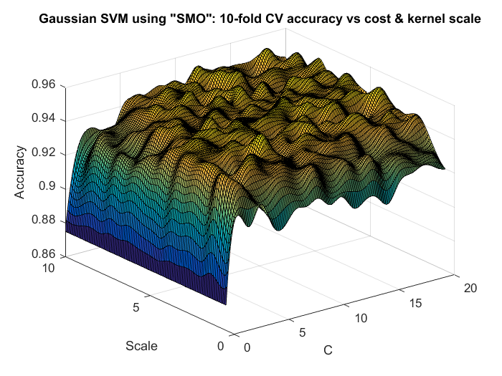
Figure showing 2-parameter optimisation for “Sequential Minimal Optimisation” Support Vector Machine using Gaussian kernel for illustrative purposes.
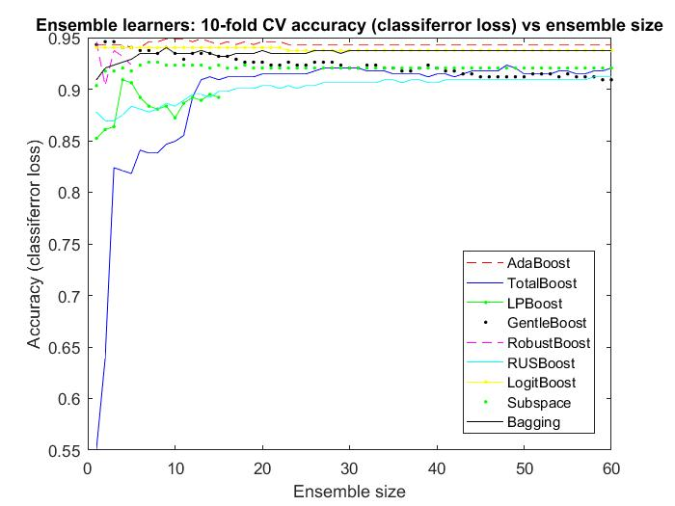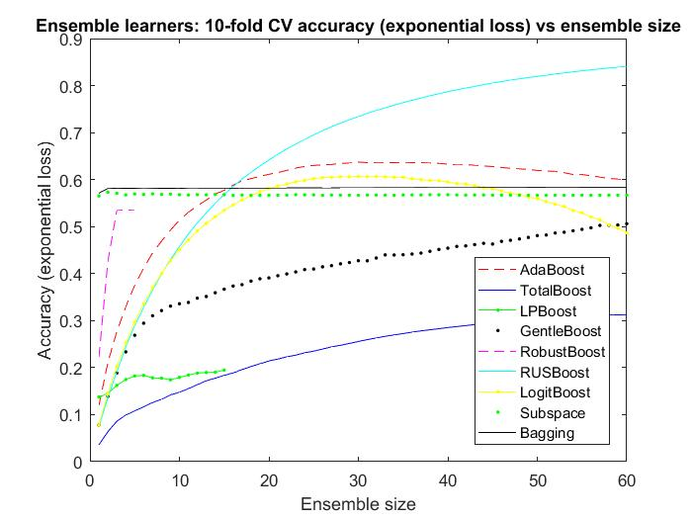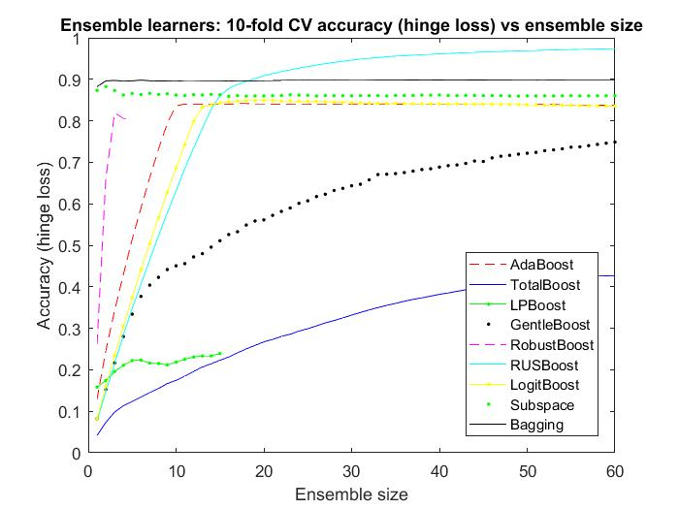
Figure showing ensemble methods validation accuracy vs number of iterations [left ensemble methods, middle ensemble methods with exponential loss, right ensemble methods with hinge loss].
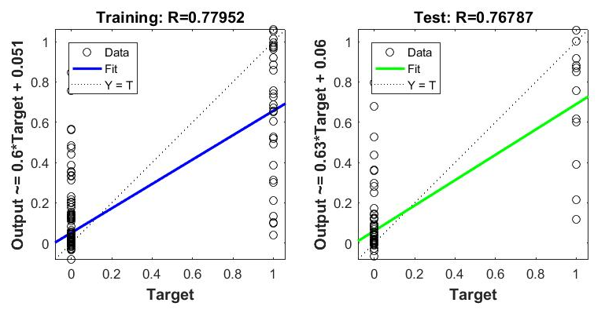
Figure showing neural network fit using 40% training, 30% validation and 30% test data for illustrative purposes. Bayesian regularisation method was selected and hidden layer contained n predictors + 1 = 4 nodes. The fit was improved by taking more training data.
- SAS Enterprise Miner
The data was divided into 40% training set, 30% validation set and 30% test set. The best model was selected from the validation set’s minimum average squared error criterion.
Table showing model fit statistics (average squared error) in the 3 sets of data [result sorted].
MODEL | MODEL DESCRIPTION | Train avg. sq. error (40%) | Validation avg. sq. error (30%) | Test avg. sq. error (30%)
GLM | Cloglog | 0.050027791 | 0.016875964 | 0.042257668
GLM | Logit | 0.051180141 | 0.020252873 | 0.031321386
GLM | Probit | 0.050060771 | 0.021268968 | 0.029947911
Neural network | AutoNeural | 0.052031144 | 0.035864731 | 0.023264374
Random forest | HPRandForest | 0.041740247 | 0.056561949 | 0.033067297
Boost | Gradient Boosting | 0.051866691 | 0.057015411 | 0.039107835
Rule | Rule Induction | 0.034843206 | 0.073979592 | 0.025355597
Decision tree | Tree-CV | 0.034843206 | 0.073979592 | 0.025355597
SVM | HPSVM | 0.084733293 | 0.083710519 | 0.071224105
Memory-based reasoning | MBR | 0.077458079 | 0.090698242 | 0.069483902
Multi-layer perceptron | MLP | 0.000122849 | 0.141046829 | 0.074790436
Binary classifier | HPBinClassifier-CV | 0.12453365 | 0.173865456 | 0.137949901
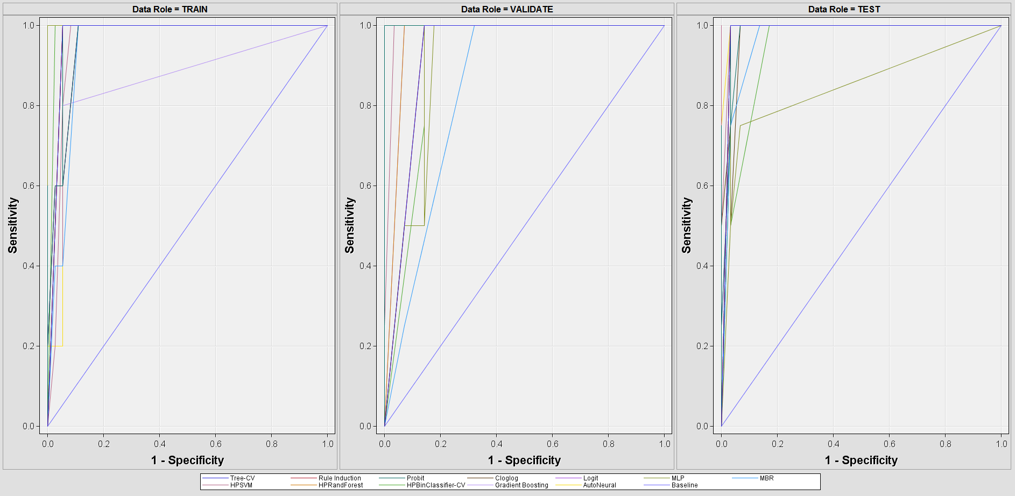
Figure showing ROC curves for the 3 sets of data – training, validation and test.
- R using rattle()
The Area Under the Curve (AUC) criterion was chosen to select the best model from the validation set; 70% data was kept for training set and 30% data was kept for validation set.
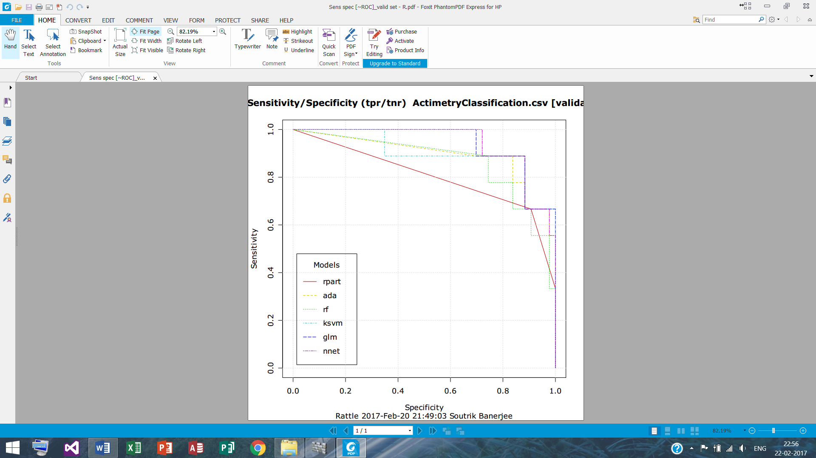
Figure showing sensitivity – specificity curves akin to the Receiver-Operating Characteristic (ROC) curves for the validation set.
Table showing validation set AUC for the methods.
Method | Area under the curve
Decision tree (CART) | 0.802
Ada boosting | 0.894
Random forest | 0.868
SVM | 0.902
Logistic regression (logit, probit) | 0.941
Neural network | 0.941
CART = classification and regression tree; SVM = support vector machine.
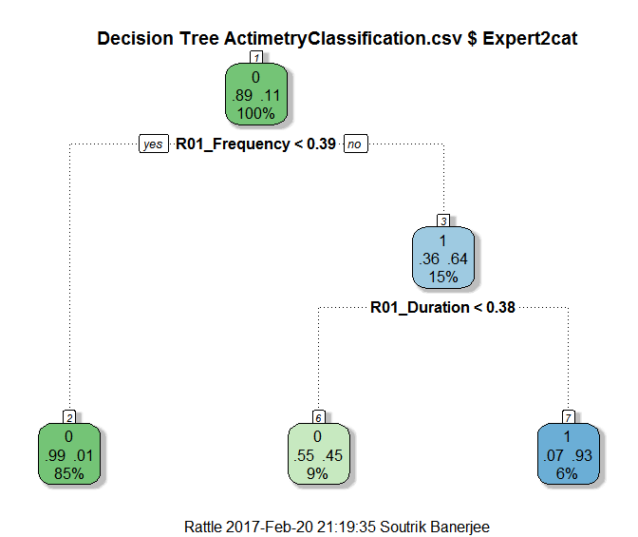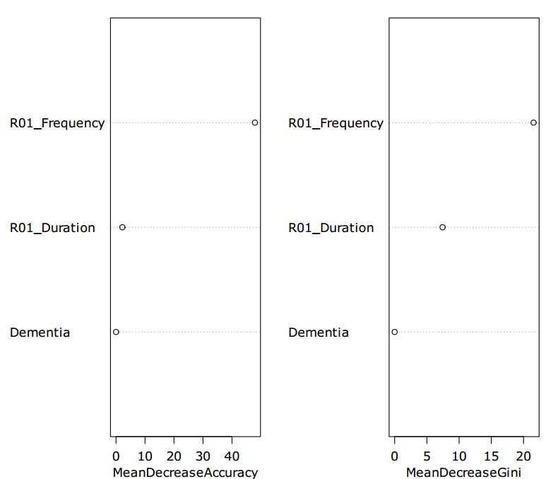
Figure showing left decision tree for illustrative purposes, right variable importance plot from random forest.
- Mathematica
Accuracy criterion was used to measure the performance of the classifier on the training set.
Method | Accuracy overall | Accuracy for ‘non-agitated state’ | Accuracy for ‘agitated state’
Naïve Bayes | 0.926 | 0.957 | 0.735
Logistic regression | 0.940 | 0.966 | 0.747
k-nearest neighbour | 0.946 | 0.970 | 0.747
SVM | 0.952 | 0.973 | 0.785
Random forest | 0.966 | 0.981 | 0.842
Neural network | 0.946 | 0.969 | 0.776
SVM = support vector machine.
- Discussion
In the current study, supervised machine learning approach was carried out on hospital PIRS data to predict nocturnal agitation in the cognitively impaired elderly, so that in future this automated identification technology could be made by an intelligent telemonitoring system. The data were analysed using Matlab, and also explored with SAS Enterprise Miner (EM), R – rattle() package and Mathematica.
Overall the different methods yielded similar performance, for a given study parameter of performance measurement in each software that was used. More elaborate analysis was carried out using Matlab, were a 10-fold CV was used, and parameter(s) was/were tuned/optimised wherever applicable based on a grid-search principle. In addition to testing different methods, three sets of ensemble learning were implemented as Matlab has a wide range of built-in functions for ensemble methods, notably for boosting methods. One set was ensemble methods themselves, then the whole set was repeated with ‘exponential loss’ function, and finally again the set was repeated with ‘hinge loss’ function. Overall, the latter two methods needed longer iteration to attain maximum performance than the direct ensemble methods, which attained maximum performance very quickly. In this perspective, the boosting approaches were found to be quite efficient. One remark here that the RUS boosting provided a 97.4% CV accuracy with ‘hinge loss’ function, but this was the only case with ‘hinge loss’ function that proved better than direct ensemble methods overall. In this perspective, direct ensemble methods should be recommended given their consistency across the different methods tested and the quick rise to maximum performance with few iterations. SVMs, decision tree and k-nearest neighbour methods also performed equally well. Neural network Matlab toolbox was tested on the validation and testing datasets. There were 4 nodes in the single hidden layer. This method provided somewhat worse performance than the direct ensemble methods, but further exploration would be necessary to maximise its performance.
Analysis with SAS EM showed that on the validation set, the GLM framework was the best performing model using average mean-squared error (aMSE) as the measure of performance. In the R – rattle() package, GLM and neural network were the best performing methods on the validation dataset, when the AUC of the ROC curve was used as the performance measurement indicator. Mathematica is still under development for supervised machine learning, which uses machine learning with internally automated performance maximisation, and the result or the trained predictive model is then available for future prediction. For this reason, the entire training set was used for training the model and model efficiency was measured by the accuracy parameter, which again could be divided into accuracy for the agitated (‘1’) and non-agitated (‘0’) states. Overall, random forest was the best performing in this case, and it could be seen that the prediction accuracy of the agitated state was consistently worse than the prediction accuracy for the non-agitated state. This was also true for all other software in the respective confusion matrices, however Mathematica publishes these results automatically making it easier to have a glance at the results in a straightforward manner.
A comparison of supervised learning with labels predicted by the night personnel was also done (not shown). These predictions were considerably worse than those made by the independent experts. This provides evidence that night personnel might be too overwhelmed and less performant in detecting patients’ activity in terms of nocturnal agitation than a PIRS equipped automated system as a reliable alternative to telesurveillance of elderly subjects in individual hospice or hospitals rooms. The results of the comparison between nurses and experts is published elsewhere.
A further remark would be that from the 352 nights’ activities that was measured, it shows that the patients who were agitated in a given night, moved frequently in short ‘bursts’ than for a long duration only on one or two occasions. For this reason, the frequency variable came out strongly as a more important variable than the duration of movement variable. Dementia status was the least important from predictive point of view, which could be due to the fact that it did not vary day to day in a given individual, but remained constant for a patient during observation. This means that simply knowing the patient to be demented does not predict well nocturnal agitation, which needs supplementary information such as PIRS equipped system for patients sleeping in a single bedroom.
Further analysis using Python, Weka, RapidMiner, Orange Miner and Knime could be carried out to compare both the different approaches as well as the software’s capabilities in exploiting supervised learning techniques.

